Model risk assessment for practical session 05 | Performing PCR

Teachers and Technicians are reminded their employer is responsible for health and safety within their institution. Risk assessments must be carried out for all practical activities included in this programme at the school and college, to include considerations for their particular laboratory, situation and group of students involved. Individual risk assessments should be carried out for each practical activity with each different group (a model risk assessment provides considerable guidance but will not suffice). If the risk assessment indicates that the practical activities are too risky to carry out in that situation, the employer is responsible for ensuring that it is not undertaken.
Schools should be aware of guidance from CLEAPSS (Consortium of Local Education Authorities for the Provision of Science Services) and, where applicable, a school or college should refer to local authority guidelines with regards to specific local rules and guidelines about health and safety.
This model activity risk assessment relates to Practical session 5: Performing PCR.
The first table outlines potential hazards grouped into chemical substances, biological materials, ergonomics, physical hazards and vulnerable groups.
The second table provides information on risks, safety precautions, emergency procedures, safe disposal and an assessment of overall risk, based on likelihood of a risk occurring and the severity should it do so.
Hazard | Name | Description | Links
Chemical substances | 2x PCR Master mix | This mixture contains the buffer, magnesium chloride, deoxyribose nucleoside triphosphates (dNTPs), and thermostable DNA polymerase, which are needed for a PCR.  This mixture is classified as not hazardous according to regulation (EC) 1272/2008. | Taq 2x Master Mix SDS

Hazard | Name | Description | Links
Biological materials | DNA sample | DNA extracted from invertebrate sample in the previous practical session.  Biological material with very low risk of contaminating living cells.
 | DNA primers | Short stretches of DNA that will bracket the region amplified during PCR.  Biological material with very low risk of contaminating living cells.
Ergonomics | Micropipetting posture | Using a micropipette involves using shoulder, wrist and hand movements that could cause muscular injury if used repeatedly over at least 2 consecutive hours per working day.
 | Environmental factors | Environmental factors, including insufficient space, low lighting levels and strong air movements or drafts could be a hazard.
Physical hazards | Equipment | The MiniPCR thermocycler, vortex and microcentrifuge are powered by 240V.
 | Heat | The MiniPCR thermocycler becomes hot during operation.
 | Using a computer in the laboratory | The MiniPCR thermocycler needs to be run using a computer, giving a combination of wet lab and electrical equipment.
Vulnerable groups | Young people | Inexperience in laboratory procedures means that all hazards can give an increased risk to young people
 | New or expectant mother | All controls in place protect new or expectant mothers during laboratory procedures.
 | Disabilities and health issues | Laboratory procedures can sometimes be more challenging for those with disabilities or health issues.
When judging risks, it is assumed that:
- All students working in a science laboratory follow good laboratory practice, including: not eating or drinking in the lab, tying back long hair, keeping lab benches clear of clutter, clearing up spills immediately, handling materials and equipment with care, and washing hands with soap after completing lab work.
- All users read, understand and follow guidance from eth Health and Safety section in the student guides.
- Disposal occurs following advice in the educator guides.
Overall risk has been judged using the risk matrix below:
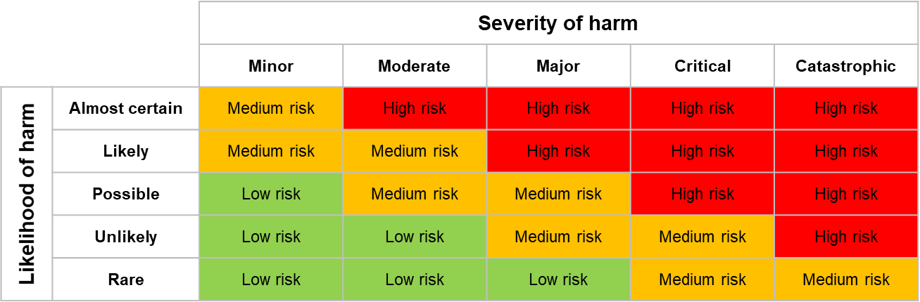

Risk(s) | Safety precautions | Emergency procedures | Likelihood | Severity | Overall risk
Contact with 2x PCR Master Mix | Use in a controlled way, similar to aseptic techniques. | In case of contact with skin wash skin with soap and water. See physician for skin irritation or allergic reactions.  If in contact with eyes rinse thoroughly using an eye bath with plenty of water for at least 15 minutes, lifting lower and upper eyelids. Consult a physician.  If surfaces or equipment get contaminated, wipe with a disinfectant-soaked paper towel & clean the surface with a suitable disinfectant. | Unlikely | Minor | Low
Contact with DNA sample or DNA primers | Use in a controlled way, similar to aseptic techniques. | In case of contact with skin wash off with plenty of soap and water.  If it gets into eyes, rinse with water using an eye bath for several minutes. Remove contact lenses, if present and easy to do.  If surfaces or equipment get contaminated, wipe with a disinfectant-soaked paper towel & clean the surface with a suitable disinfectant. | Unlikely | Minor | Low
Risk(s) | Safety precautions | Emergency procedures | Likelihood | Severity | Overall risk
Unsafe disposal of chemical / biological substances | Discard single-use disposable items, such as pipette tips, and microfuge tubes, into labelled disposable plastic jars for safe disposal.  All pipette tips, tubes and gels that contain biological materials should be placed into an autoclave bag for autoclaving prior to disposal. | If contact is made with skin during disposal of chemical or biological substances, wash with plenty of soap and water.  If chemical substances go into eyes during disposal, rinse thoroughly with plenty of water for at least 15 minutes, lifting lower and upper eyelids. Consult a physician. | Unlikely | Minor | Low
Shoulders / wrists / hands sore from micropipette use | Don’t micropipette for long periods (>2 hours) without a break. Stretching is recommended every 20 minutes to minimise risk. | If shoulders, wrists or hands become sore, stop pipetting and stretch. | Unlikely | Minor | Low
Inappropriate environment | Ensure that laboratory work is carried out with sufficient space, lighting and without strong air movements or drafts. | Stop work immediately if the environment becomes unsuitable (eg; if lights go out). | Unlikely | Minor | Low

Risk(s) | Safety precautions | Emergency procedures | Likelihood | Severity | Overall risk
Use of MiniPCR thermocycler, vortex and microcentrifuge – risk from electrical equipment | Manufacturer's instructions are read by supervisors and available for reference.  Check that portable electrical equipment (110V and above) fitted with a plug is within 12 months of use from new or has an ‘in date’ PAT Passed label attached.  Portable electrical equipment which is either untested or where the test is 'out of date' should not be used.  Never use electrical equipment with a damaged cable or cracked plug. | Immediately isolate the power and stop using any electrical equipment which is overheating or if signs of damage become apparent during use. | Unlikely | Moderate | Low
Burns from MiniPCR thermocycler | Ensure that hot surfaces and equipment are clearly labelled.  Avoid contact with hot surfaces. | Remove the heat source and run the affected area under cool or tepid water for 20 minutes. For bad burns notify the local First aider. | Unlikely | Moderate | Low

Risk(s) | Safety precautions | Emergency procedures | Likelihood | Severity | Overall risk
Short circuit or fire hazard from combination of wet lab and electrical equipment when running the MiniPCR thermocycler using a computer. | Avoid contact between liquids and the computer, by placing the computer away from liquids in the laboratory.  Ensure that all cables are in good condition, as spilt liquids on a damaged cable are the most likely way for water and electricity to mix. | Should an electrical fire start, shut off the electricity. Raise the alarm and move everyone to safety.  If it safe to do so, a powder fire extinguisher should be used to tackle an electrical fire, as the powder will smother the fire without reacting with it. | Rare | Moderate | Low
Young people don’t follow laboratory protocols correctly due to inexperience | Clearly explain instructions, answer questions and monitor students as they complete the practical work. | If a student is not following the laboratory procedures or behaving in a way that endangers themselves or others they should be prevented from carrying out the practical work. | Unlikely | Moderate | Low
Impaired health or physical disability makes practical work more risky | Adaptations may be required to facilitate practical work and should be assessed on a case by case basis with advice from support staff, SEN or other appropriate person. | Realistic scenarios can be planned for and assessed on a case by case basis.

